Class 8 COMPUTER June- 21 to 30
Make a model of Local Area network.
Write the advantage and drawbacks of MAN network
Write about the features of Client/ Server Architecture.
What prevention and security would you take while login and accessing your network.

July 1-10
Lesson -3 Access to Ms Access
Note:- read the page no 23,24,and 25 and complete the Assignment.

Write the definition of Database.
Define about record keeping system used in computer.
Mention about DBMS and its types.
Write down the advantages of DBMS.
Define the following terms:-
- Table 2. Field 3. Records 4.Queries 5 reports.

हिंदी ग्रीष्मावकाश कालीन ‍गृह कार्य 2020-2021
कक्षा 8
(21June to 30June)
1. संवाद लेखन-(1)अध्यापिका और छात्रा के मध्य हुए संवाद को लिखिए।(2)पिता और पुत्र के मध्य हुए संवाद को लिखिए।(पृष्ठ संख्या 221-222)
2. प्रतिवेदन लेखन-(1) विद्यालय में मनाया गया वार्षिकोत्सव।
(2) यात्रियों से भरी बस पेड़ से जा टकराई।(पृष्ठ संख्या- 225)
नोट-उपर्युक्त सभी कार्य अपनी व्याकरण की कक्ष कार्य पुस्तिका में करें।
(1July to 10 July)
(हिंदी साहित्य)
१. साहित्य की पुस्तक में वर्णित सभी पाठों के नाम अपनी साहित्य की कक्ष कार्य पुस्तिका में सुसज्जित रूप में लिखिए।
२. परियोजना कार्य (प्रोजेक्ट वर्क)-हिंदी साहित्य की पुस्तक में वर्णित किन्ही पांच कवियों एवं पांच लेखकों का जीवन परिचय उनके चित्र के साथ सुसज्जित करके अपनी साहित्य की कक्ष कार्य पुस्तिका में लिखिए।
३. साहित्य की पुस्तक में वर्णित सभी पाठों का ध्यान पूर्वक अवलोकन करके कठिन शब्दों को रेखांकित कीजिए एवं उनकी वर्तनी को कंठस्थ करने का प्रयास करें।
नोट-1उपर्युक्त सभी कार्य अपनी हिंदी साहित्य की कक्ष कार्य पुस्तिका में करें।
2. प्रतिदिन(1June-10July) एक पृष्ठ सुलेख लिखें। (सुलेख पुस्तिका अलग से बनाएं एवं उसी में ही सुलेख लिखें।)
CLASS 8-- SCIENCE HHW
DATE-21/06/20 to 30/06/20
Learn these points
Lesson 2--microorganism:friend and foe
￼ Microorganisms- A living organism that is very minute to be seen by the naked eye, especially a single celled organism, such as a bacterium is called microorganism. Microorganisms are classified into four major groups mainly bacteria, fungi, protozoa and some algae.
￼ Some of the microorganisms are unicellular like bacteria, while some have well developed, multi-cellular body like moulds.
￼ They can survive under different types of climatic environment, ranging from ice cold climate to hot summers and deserts to marshy, muddy lands. They are also found inside the bodies of animals including humans, air, water, soil, food and other things.
￼ Virus: You may be surprised to know that the viruses can be crystallized and stored like some non-living things, such as common salt and sugar. On the other hand, they multiply like living organisms when they are within a living body.
￼ Bacteria: Bacteria are single celled microorganisms. They are put under plant kingdom because they have rigid definite cell wall like plant cells. Bacteria can be seen under microscope which enlarges their image from a hundred to thousand times.
￼ Fungi: Fungi are non-green plants. They cannot synthesize their own food. They have to depend for their food on others. Most fungi take their food from dead organic matter. Some live on other organisms as parasites.
￼ Algae: Algae are green substances floating on the surface of a pond, lake, river, stagnant water, moist soil, stones. They tend to grow on wet surfaces. Therefore, they can synthesize their own food. They are found in water or in very moist places.
￼ Protozoa: Protozoa are unicellular animals. Some are free-living, others are parasites. Several parasitic protozoans cause diseases in human beings, domestic animals and plants. For example, Plasmodium, a protozoan, causes malaria.
￼ Microorganisms are commercially used for the large scale production of alcohol, wine and acetic acid (vinegar), while has medicinal uses too.
￼ Microorganisms can harmful too. Some of the microorganisms cause diseases in humans, plants as well as in animals. Such microorganisms which cause disease are known as pathogens. Some microorganisms spoil leather, food and clothing.
￼ Food Poisoning- Food poisoning can be caused as a result of consumption of food spoilt by some microorganisms. Microorganisms that grow on our food sometimes produce substances that are toxic in nature. These make the food poisonous and can cause serious illness to living organisms.
￼ Food Preservation- Microorganisms may grow on our food and spoil it. Spoiled food emits bad smell,bad taste and changed colour.
￼ Antibody- When a disease causing microbes enter our body, our internal defensive mechanisms produces substances called Antibodies to fight disease causing microbes.
￼ Vaccine- When a disease-carrying microbe enters our healthy body, the body produces antibodies, body fights and kills them by these antibodies. The body also remembers how to fight the microbe if it enters again. The antibodies remain in the body for a long time and protect us from the disease causing microbes. The substance which is injected into the body to trigger the body to initiate this entire process is called a vaccine.
￼ Pasteurization- this is a process in which milk is heated to about 70 degree Celsius for about 15 to 30 seconds and then suddenly chilled and stored. This process was discovered by Louis Pasteur.
￼ Nitrogen Cycle- Some bacteria and blue green algae present in the soil fix nitrogen from the atmosphere and convert into compounds of nitrogen. Once nitrogen is converted into these usable compounds, it can be utilised by plants from the soil through their root system. On the othe hand when plants and animals die, bacteria and fungi present in the soil convert the nitrogenous wastes into nitrogenous compounds to be used by plants again. Thus due to this Nitrogen Cycle, the percentage of nitrogen in the atmosphere remains more or less constant.
-Learn/write these q/a
Lesson 2..microorganism:friend or foe.
Q. Can microorganisms be seen with the naked eyes? If not how can they be seen?
Ans. Microorganisms cannot be seen with naked eyes. They can be seen with the help of a microscope.
Q. What are the major groups of microorganisms?
Ans. There are following four major groups of microorganisms:
(i) Bacteria (ii) Fungi (iii) Protozoa (iv) Algae.
In addition viruses are also considered as fifth group of microorganisms.

Q. Name the microorganisms which can fix atmospheric nitrogen in the soil.
Ans. Bacteria like Rhizobium and Azotobacter and blue green algae can fix atmospheric nitrogen in soil.
Q. Write 10 points on the usefulness of microorganisms in our lines:
Ans. Uses of microorganisms:
(i) Microorganisms help in the preparation of curd, bread, cake etc.
(ii) They are used to produce alcohol at large scale.
(iii) Yeast is used to prepare vinegar.
(iv) Microorganisms are used to make wines.
(v) They act as cleaning agent and decompose the waste products into manure.
(vi) They destroy the plant and animal dead bodies by decomposing them.
(vii) They increase soil fertility by fixing nitrogen of atmosphere.
(viii) They are used in making medicines like antibiotics and vaccines.
(ix) They are used as preservatives for food items.
(x) They help in various metabolic activities in our body.
Q. Write a short paragraph on the harms caused by microorganisms.
Ans. Microorganisms are also very harmful to us. They cause a number of diseases inhuman as well as in other animals. Common cold, Tuberculosis, Measles, Chicken Pox, Polio, Cholera, Typhoid, Hepatitis B, Malaria, are some common human diseases caused by microorganisms. Anthrax is a serious disease in animals caused by microbes. They also make food items unfit for use by food poisoning. They also spoil clothes and leather products. They also cause diseases in plants like blights in potatoes, sugarcanes, oranges etc. They also reduce the crop production.
Q.. What are antibiotics? What precautions must be taken while taking antibiotics?
Ans. The medicines which kill or stop the growth of microorganisms in our body are called antibiotics. These are very useful to us as they prevent us from the effects of microorganisms. Antibiotics are made from bacteria and fungi. The penicillin is the first antibiotics which is discovered by Alexander Fleming in 1929. These days a number of antibiotics are used to cure various human and animal diseases. Streptomycin, Tetracycline, Erythromycin etc. are some common antibiotics. Precautions: We should take antibiotics only by the advice of a qualified doctor. Antibiotics should only be taken when needed. Otherwise, they may be harmful and become less effective in future.

Class 8-- Science homework
Date--01/07/20 to 10/07/20

SECTION C--

PROJECT--1
Prepare herbarium specimen of some crop plants(atleast 5).Record folllowing details on the side of the specimen.
1.common name of plant
2.scientific name of plant
3. place from where plant is collected.
4. date of collection.
5.any other information about the plant.

PROJECT 2--
Make a project on novel corona virus disease (covid-19).Include following points--
1.corona virus
2.mode of transmission
3.methods of prevention
4.its impact on our economy and social life.

ACTIVITY--1

Perform an activity to show that graphite is a conductor of electricity.
(see pg no. 62. Activity.1 of textbook)

ACTIVITY 2--
Visit a farm and learn about fertilizers from the farmer.Also learn about different fertilizers and their application at different stages of the growth of crop plants.Make a record of the information collected.
MATHEMATICS
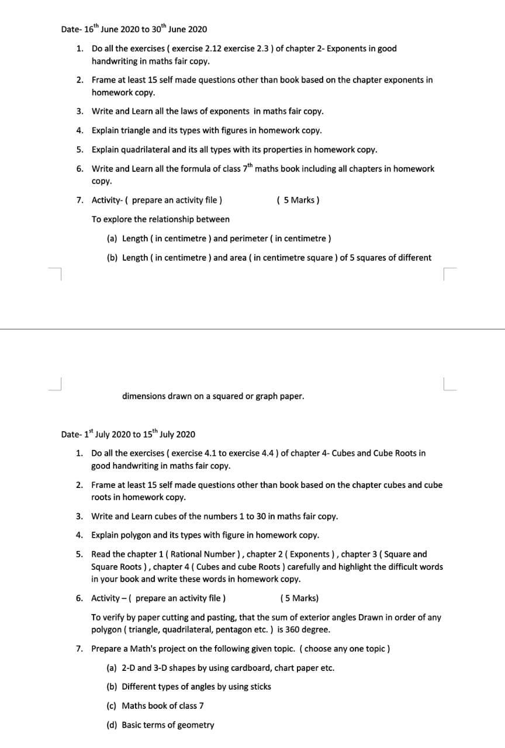

Holiday Homework. July 1 to July 10
Class 8. Subject. Civics
Note: All the Q /A, Activity, Exercise, Project has been given from your school Text book.
Please refer Chapter 1 of Civics for Key terms you can take help of Internet.
Q.1 Write and learn All the following key terms.
Amendments, Consensus, Constitution, Democratic, Heritage, Federal, Fundamental rights, Fundamental duties, Secularism, Dissent.
Q.2 Write all the MCQ , Match the following and 'Very Short Answers' in your Copy.
Q.3 Write and learn Short notes on the following topics. [Maximum 5 to 6 lines].
- • Sovereign state
- • Socialist state
- • Secular state
- • Democratic state
- • Republic

Q.4 Why do we need to have Constitution ?
Case studies
Read the Case studies on Page no. 217.
HOTS:-
‘Indian constitution is federal in structure'.Explain.
Poster making:-
Two social evils given in the Chapter. Choose any one of them and prepare a poster appealing to the people to stop the evil.

Holiday Homework. June 21 to June 30
Class 8. Subject :- Geography
Note: All the Q /A, Activity, Exercise, Project has been given from your school Text book.
Please refer Chapter 1 of Geography.
Q.1 Write and learn All the following key terms.
Resources, Abiotic Resources, Biotic resources, Desertification, Sustainable development, Conservation.
Q.2 Write all the MCQ , Fill in the blanks and 'Very Short Answers' in your Copy.
Q.3 Write and learn short notes on following topics.[Maximum 5 to 6 lines]
- • Actual resources
- • Potential resources
- • Natural resources
- • Human resources
- • Agricultural resources
- • Mineral resources
- • International resources

Q.4 distinguish between renewable resources and non-renewable resources.
Value – Based questions:-
List down 6 points you can adopt to recycle and reuse different items used by you to contribute in the conservation of natural resources.
Project Work :-
On a sheet of paper, draw and paint pictures of different objects like plants, rocks,animals, vegetable, soap and soap- cese, boat bat,cricket ball, toothpaste,etc. Write the type of resource below each item for example your toothpaste is a non renewable resource

