कक्षा 9 हिंदी गृहकार्य
(21जून से 30 जून )
कृतिका - पाठ 2 मेरे संग की औरतें को ध्यानपूर्वक पढ़कर कठिन शब्दों के अर्थ लिखकर याद कीजिए। पाठ के प्रत्येक अनुच्छेद से पांच-पांच छोटे प्रश्नोत्तर बनाकर लिखिए। पाठ के अंत में दिए गए प्रश्न उत्तर कॉपी में कीजिए।
व्याकरण - पाठ-1 उपसर्ग,प्रत्यय और समास की परिभाषा और भेदों को उदाहरण सहित लिखकर याद कीजिए।
गद्यखंड के पाठ 1और 2 से उपसर्ग, प्रत्यय और समास के शब्दों को छाँटकर उनके मूल शब्द और उपसर्ग, प्रत्यय अलग करके लिखिए और समास के शब्दों का विग्रह करके भेद का नाम लिखिए।
(1जुलाई से 10 जुलाई)
निबंध लेखन - आधुनिक भारत की प्रगति में बाधाएं, देश के प्रति नागरिकों के कर्तव्य, आंखों देखे किसी मैच का वर्णन, विद्यार्थी जीवन और पुस्तकालय, विज्ञापनों का जनजीवन पर प्रभाव आदि विषयों पर 200-250 शब्दों के निबंध लिखिए।
लेखन - व्याकरण की पुस्तक से पांच औपचारिक और पांच अनौपचारिक पत्र लिखिए तथा
पांच विषयों पर संवाद लेखन लिखिए।
व्याकरण की पुस्तक से पाँच अपठित गद्यांश के प्रश्नोत्तर हल करके लिखिए।
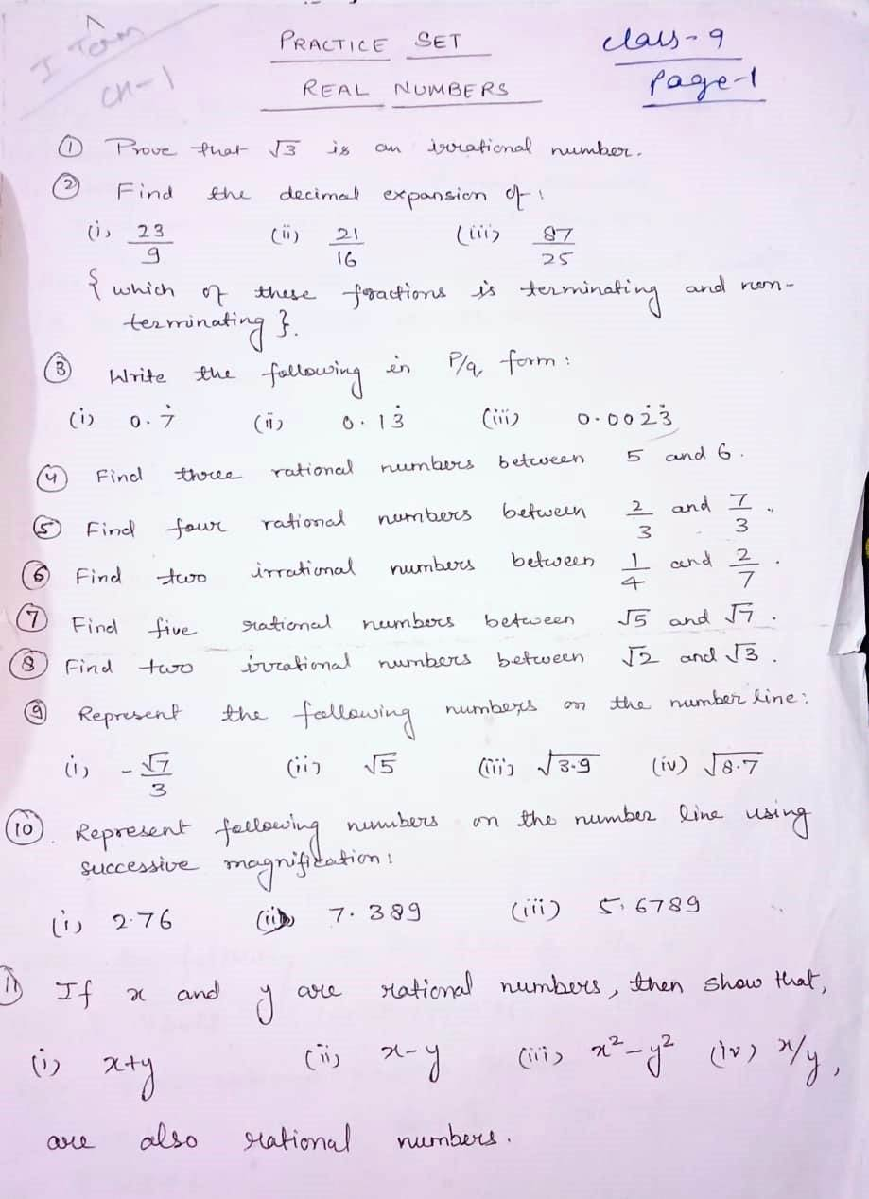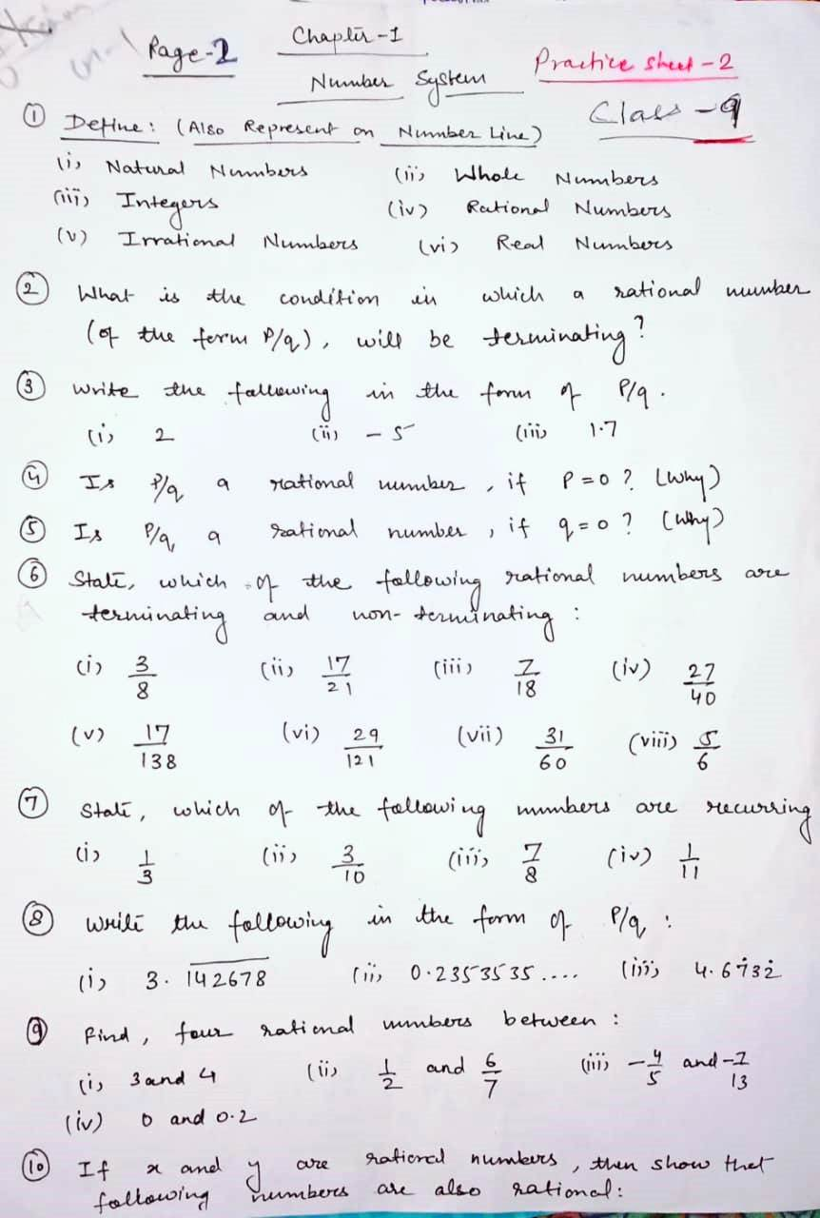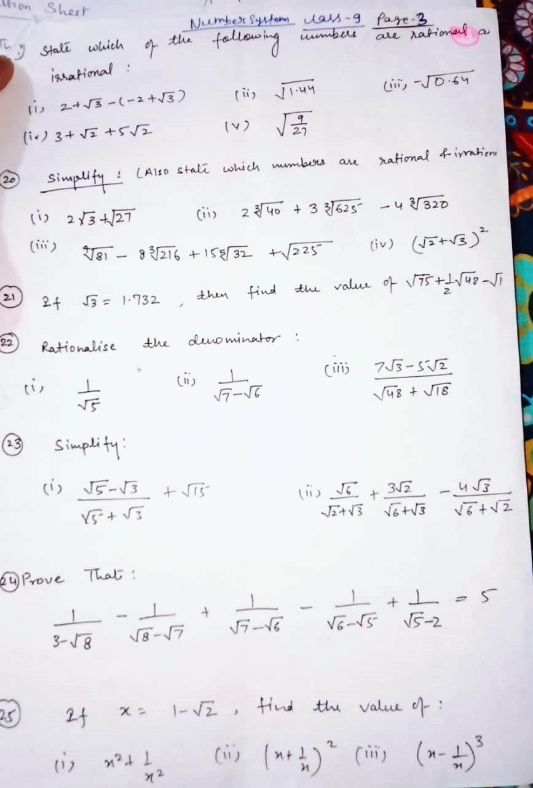
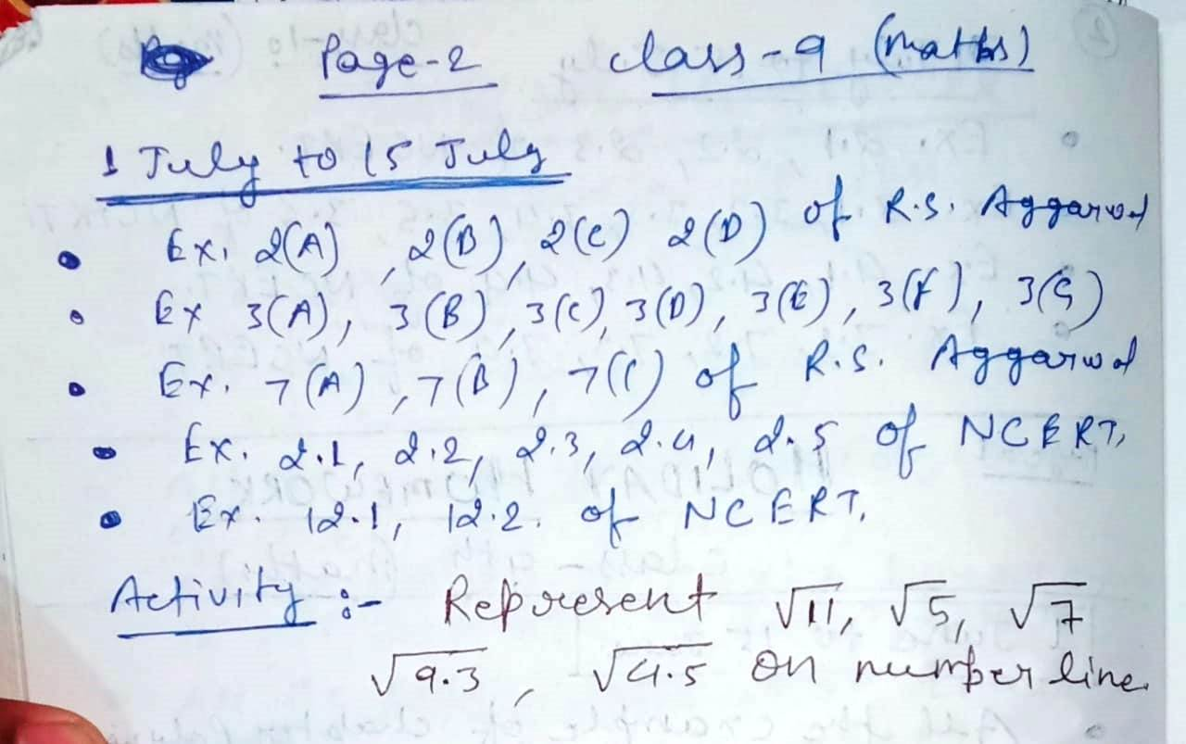

Class IX
Holiday day home work
English
……. …….. ……. ………. ………. ……..
Date:- 21 to 30 June
(Language 21 to 25 June)

- Read the chapter Passive Voice from your book on page 173 and do exercises 1,2,3,4, in both of your notebook (HW &Fair).
- Read chapter Editing on page 321 and do exercises on pages 321,322,323,324 in both of your note book.
- Read chapter Omission on page 326 and exercises on page 326,327,328.
- Write a story with help of cue/s in not more than 150-200 words given on page 95 of your book practise exercise 1. Any ONE from question to 15.
- Read page 46 of your book solve the unseen passage write down the question and answers in both of your note book. Read the passage twice and then only answer.

(Literature 26 to 30 June)

- Read the poem Rain On The Roof write down the summary of the poem in your own words in not more than 100 words.
- Who is crying in the poem and what kind of feeling the poet is going through in the poem?
- Where is the poet and what he is doing there ?
- What is the making an echo in the poet hearts
- Write down the meaning of the following words and make sentences with each of them. a. Tinkle , b. Shingles , c. Refrain, d. Woof.

Date:- 1 to 10 July
(Language 1 to 5 July)
- Project. Write down Character Sketch of any of the poet from the poem that you have read from your beehive book. (Prepare it in file page as it will be considered as your classwork assignment and you will get marks over it).
- Project . Write down 50 words with meaning from Moments books and write down in your literature notebook as a assignment for Unit 1
- Do revision and practise all the creative writing work which was given to you during Lockdown
- Learn 10 thoughts given by great personality and write it down in both of your note book.
- Write a biography of the person whom you admire most in not more than 150 words.

(Literature 6 to 10 July)

- Read the chapter The Lost Child and frame 20 question and find 10 new words with their meaning and write it down in both of your notebooks
- Revise all poem that we have done and learn all the answers of ncert and self framed question for unit 1 test.
- Frame 2 -2 reference to context from the poem that you have done and write question with answers.
- Write a poem that you enjoyed and liked most from your beehive book and write it down in page and try to draw some image to explain it.
- Write down 5 book name which is written by Great Indians Personality like great Mr Atal Vajpayee, Great A P J Abdul Kalam .
Date :-11 to 15 July
(Language 11 to 15 July)
- Read Chapter Vocabulary and learn 5 new word everyday with their meaning and write it down in vocabulary note .
- Learn and write 10 Idioms in your homework note book.
- Learn a poem or a story or prepare a speech for your ASL for Unit 1 marks will be given.

Note : follow all the instructions carefully and do your homework with neat and clean handwriting as marks will.be given for best presentation.
*Prepare poem Wind, Rain on the roof , The Road not taken, and chapter Lost Child for your Unit 1 exams.
Your marks will be based on the assignment and project .

Holiday Homework
Class-IX { sub: science}
NOTE : All the Q/A ,exercise , activity, project has been given from your text book. Please refer the book. All the assignment will be thoroughly checked whenever school respond and marks will be assigned according to your work.
DATE : JUNE 20 TO JULY 10

Physics
Q1. Read chapter motion and make a proper note.
Q2. Do exercise given on page no 111 and 112 of your physics books.
Q3. Do NTSE-SAT (Target: scholastic aptitude test) given on page no 117 ,118 and 119 of your physics books. [note: make another copy for these competitive based questions only]
Q4. Write 15 assertion-reason based question by yourself in your homework copy.
Q5. Make a chart paper on topic distribution of force and use of laws of motion.
Q6. How can you express that in a whole process the leaner momentum of a body is conserve?
Q7.why do you fall in the forward direction when a moving bus breakes to a stop and fall backwards when it accelerates from rest?

Chemistry
1. Read the chapter is matter around us pure from your Biology book and do the practice exercise 2A (page2/13) and 2B (page2/25) in your homework notebook.
2. classify the following substance as element compound or mixture.
Iron, gunpowder ,soda water ,gold, air ,Diamond ,graphite, Chalk, alcohol ,team.
3. hydrogen is a combustible gas and oxygen is supporter of Fire. water contain both hydrogen and oxygen but it is used to extinguishing the fire, explain.
4. A given solution contain 40 gram of sugar in 320 gram of water ,calculate the concentration of solution.
5. A solution of sugar in water is 5% by mass how much sugar is present in 250 gram of the solution.
6. what is mixture, explain its type.
7. write short notes on saturated and unsaturated solution ,suspension, colloidal solution, true solution solubility, tyndall effect.

Biology
1. Read the chapter tissue from your Biology book and do the practice exercise 2A (page60) and 2B (page74) in your homework notebook.
2. what is meristematic tissue explain the type of meristematic tissue.
3. name the living component of both the complex permanent tissue found in plant. what is its function?
4. differentiate between collenchyma chlorenchyma and aerenchyma.
5. what is cork what are its advantage.
6. parenchyma is called a simple tissue ,while xylem is called a compound tissue ,why.
7. blood protein are incapable of blood clotting inside the the blood vessels but form the blood clot at the injury how is it possible

Date: JULY 10 TO JULY 30

PHYSICS
- explain why some of the leaves may get detached from a tree if we vigorously shake its branch.
- A bullet of mass 20kg is horizontally fired with a horizontal velocity 150 m/s from a pistol of mass 2 kg .what is the recoil velocity of the pistol?
- Derive the mathematical formula of conservation of momentum.
- Make a chart on classification of force on the basis of:
- Balancing b. contact
- Describe the mathematical relation of Newton’s second law of motion
- Give 5 examples which proves the every action has equal and opposite reaction.
- From a rifle of mass 4kg a bullet of mass 50kg is fired with an initial velocity of 35m/s. calculate the initial recoil velocity of the rifle.
Biology

- Do all question of NCERT file from page 77 in your notebook fair.
- Explain the nervous tissue.
- Write short notes on muscular and contractile tissue.
4.Activity.( do in activity file)
- To show the presence of different type of plant tissue in the stem or root of higher plant.
- To show the presence of epidermis and stomata In a leaf.
- Project (Do in project file)
- Write short notes on the plant tissue.

Chemistry
- Do all question of NCERT file from page 2/39 in your notebook fair.
- Do the chapter practice test(page2/64) in your notebook fair.
- How to separate a mixture of two miscible liquid?
- How to separate component of air or gases from air.
- Activity.( do in activity file)
- To show The Separation of two immiscible liquid using a separating funnel.
- To show Separation of two miscible liquid using distillation.
- Project (Do in project file)
- Write short notes on type of pure substance
- Write short notes on fractional distillation

