PRAYAG PUBLIC SCHOOL & COLLEGE LALGOPALGANJ PRAYAGRAJ
HOLIDAY HOMEWORK
CLASS – X (2020-2021)
SUBJECT- SCIENCE
NOTE : All the Q/A ,exercise , activity, project has been given from your text book. Please refer the book. All the assignment will be thoroughly checked whenever school respond and marks will be assigned according to your work.
Physics
- Read chapter motion and make a proper note.
- Do exercise given on page no 54 and 55 of your physics book.
- Do NTSE-SAT (Target: scholastic aptitude test) given on page no 65,66,6768&69 of your physics book [note: make another copy for these competitive based question only]
- Write 15 assertion-reason based question by your self in your homework copy.
- Make chart paper on use of study of motion in physical world
- The resistance of a wire of 0.01 cm radius is 10Ω. If the resistivity of the material of the wire is 5×10⁸ Ωm. find the length of the wire.

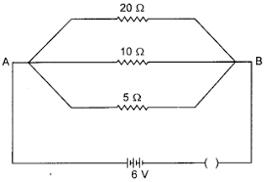
- An electric lamp of 100 Ω, a toaster of resistance. 50 Ω , and a water filter of resistance 500 Ω are connected in parallel to a 220 V source. What is the resistance of an electric iron connected to the same source that takes as much current as all the three appliances, and what is the current through it?
- What are the advantages of connecting electrical devices in parallel with the battery instead of connecting them in series?
- What is (a) the highest, (b) the lowest total resistance that can be secured by combinations of four coils of resistance 4 Ω , 8 Ω , 12 Ω , 24 Ω?
- Redraw the circuit of Question 12, putting in an ammeter to measure the current through the resistors and a voltmeter to measure the potential different across the 12 Ω resistors. What would be the readings in the ammeter and the voltmeter?
Chemistry
- Read the chapter chemical reaction and equation from your chemistry book and do the practice exercise 1A (page15 ) and 1B (page32) in your homework notebook.
- Name the substance oxidized and the substance reduced in the following reaction.
- MnO2+4HCl➡️MnCl2+Cl2+H2O
- 2H2S + SO2 → 2H2O + 3S
- 2PbO+C2 →PbO+CO2
- PbS + 4H2O2→PbSO4+4H2O
- CuO+H2→Cu+H2O
- Zn+2AgNo3→Zn(No3)2+2Ag
- Fe+CuSO4→FeSO4+Cu
- Name the following chemical reaction.
- 2CuO→2Cu+O2
- 2KClO3 →2KCl+3O2
- Zn+2AgNO3→Zn (NO3)2+2Ag
- Ni(NO3)2+2NaOH→Ni(OH)2+2NaNO3
- NH3+HCl+NH4Cl
- 2KNO3→2kNO2+O2
- What are the characteristic of chemical reaction explain with example.
- Write the balanced chemical equation for following chemical reaction.
- Zinc metal react with hydrochloric acid to produce a solution of zinc chloride and hydrogen gas.
- When solid Mercury II oxide is heated ,liquid Mercury and Oxygen gas are produced.
- Aqueous solution of sulphuric acid and sodium hydroxide react to form aqueous solution of sodium sulphate and water.
- Phosphorus burns in chlorine gas to form Phosphorus pentachloride.
Biology
- read chapter life processes from your Biology book and do practice exercise 1A (page 33) in your homework notebook.
- Read the chapter life process and do practice exercise1B (page 53)in your homework notebook.
- How does diaphragm help in breathing,justify it.
- Why is diffusion insufficient to meet the oxygen requirement of multicellular organisms like humans.
Date June 10 to June 20
PHYSICS
- Current of 200mA if flowing in a conductor . How free electrons will flow through it per seconds.
- Find the resultant resistance of following
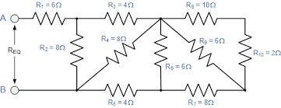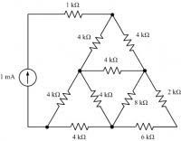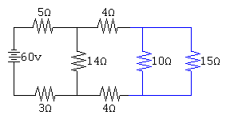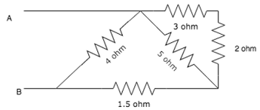

- Calculate the area of cross section of a wire of length 2m, its resistance is 25Ω and the resistivity of material of wire is 1.84*10⁻6 Ωm.
- Calculate the energy consumed by 120W toaster in 20 minutes.
CHEMISTRY
- Do all question of NCERT file from page 35 in your notebook fair.
- What is the chemical reaction? explain the type of chemical reaction in your notebook fair.
- Differentiate between physical change and chemical change.
- Activity.
- To show heating of ferrous sulphate is a decomposition reaction
- To show a chemical reaction between zinc and an acid.
- To study the chemical reaction between Lead Nitrate and potassium iodide.
- To show exothermic reaction between quicklime and water.
- project
- write short notes on rancidity and corrosion. Write their effect and prevention do it in your notebook fair.
- Write short notes on balancing the chemical reaction.
BIOLOGY
- Do all question of NCERT file from page 57 to 59 in your notebook fair.
- Read the given passage and answer the following question ,do it in your notebook fair.
some sugar solution is taken in test tube and a little of substance X in powder form is added to it. the mouth of test tube is closed with cork and allowed to stand for some time. on opening the cork a characteristic smell of substance Y is obtained and a gas is also observed to be formed .the gas Z extinguishes a burning matchstick.
- What would be the X ,Y and Z
- what is the process of converting sugar into substance Y by the action of X known as .
- what type of respiration is exhibited by X in the above process.
- Name the light spectrum where photosynthesis is maximum.
- Name the four raw material which is used by plant.
- Do all question of short answer Type- l and short answer type -ll from page 77 to78 in your notebook fair.
- Do the activity in activity file. Activity -1
to show that carbon dioxide is necessary for photosynthesis .
Activity -2
to show that carbon dioxide is produced during respiration.
- Do the the following project in project file.
project -1
draw the well labelled diagram of human respiratory system explain the mechanism of breathing.

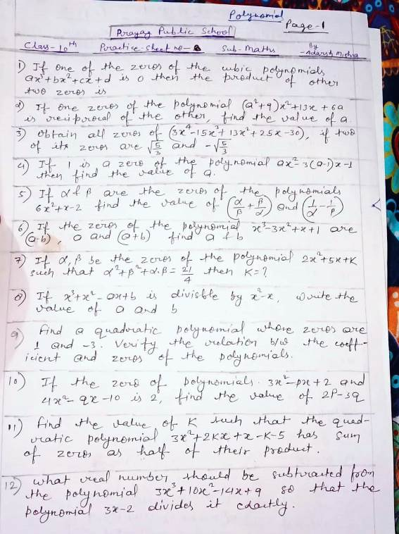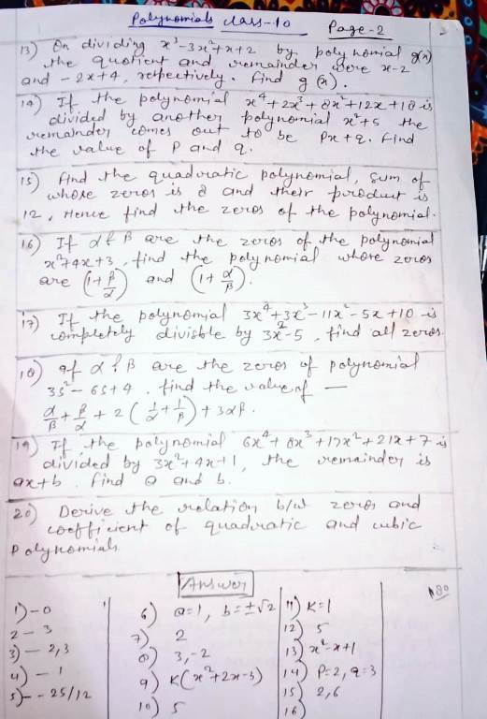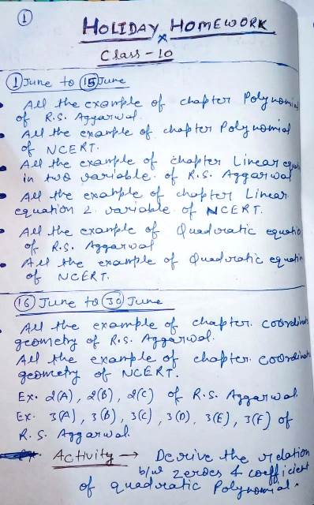
*कक्षा 10
हिंदी गृहकार्य*

(1 जून से 10 जून )

क्षितिज (गद्यखंड) - पाठ-10 नेताजी का चश्मा को ध्यानपूर्वक पढ़कर कठिन शब्दों के अर्थ लिखकर याद कीजिए। पाठ के प्रत्येक अनुच्छेद से पांच-पांच छोटे प्रश्नोत्तर बनाकर लिखिए। पाठ के अंत में दिए गए प्रश्नोत्तर कॉपी में कीजिए।
पाठ के लेखक स्वयं प्रकाश के जीवन परिचय, रचनाएं और साहित्यिक परिचय पर एक परियोजना तैयार कीजिए।
पाठ 11 बालगोबिन भगत को पढ़कर उसके शब्दार्थ याद कीजिए, प्रत्येक अनुच्छेद से प्रश्नोत्तर बनाकर लिखिए,और पाठ के अंत में दिए प्रश्नोत्तर कीजिये।

(11 जून से 20जून)

*क्षितिज (काव्य खंड) -
पाठ* 8 कन्यादान को ध्यानपूर्वक पढ़कर शब्दार्थ और व्याख्या लिखकर याद कीजिए। कविता के प्रत्येक काव्यांश से पांच-पांच छोटे प्रश्नोत्तर बनाकर लिखिए। पाठ के अंत में दिए गए प्रश्न उत्तर कॉपी में कीजिए।

कवि ऋतुराज की काव्य शैली पर अपने विचार व्यक्त कीजिए।

सूरदास के पद पाठ के शब्दार्थ, व्याख्या और प्रश्न उत्तर लिखकर याद कीजिए।
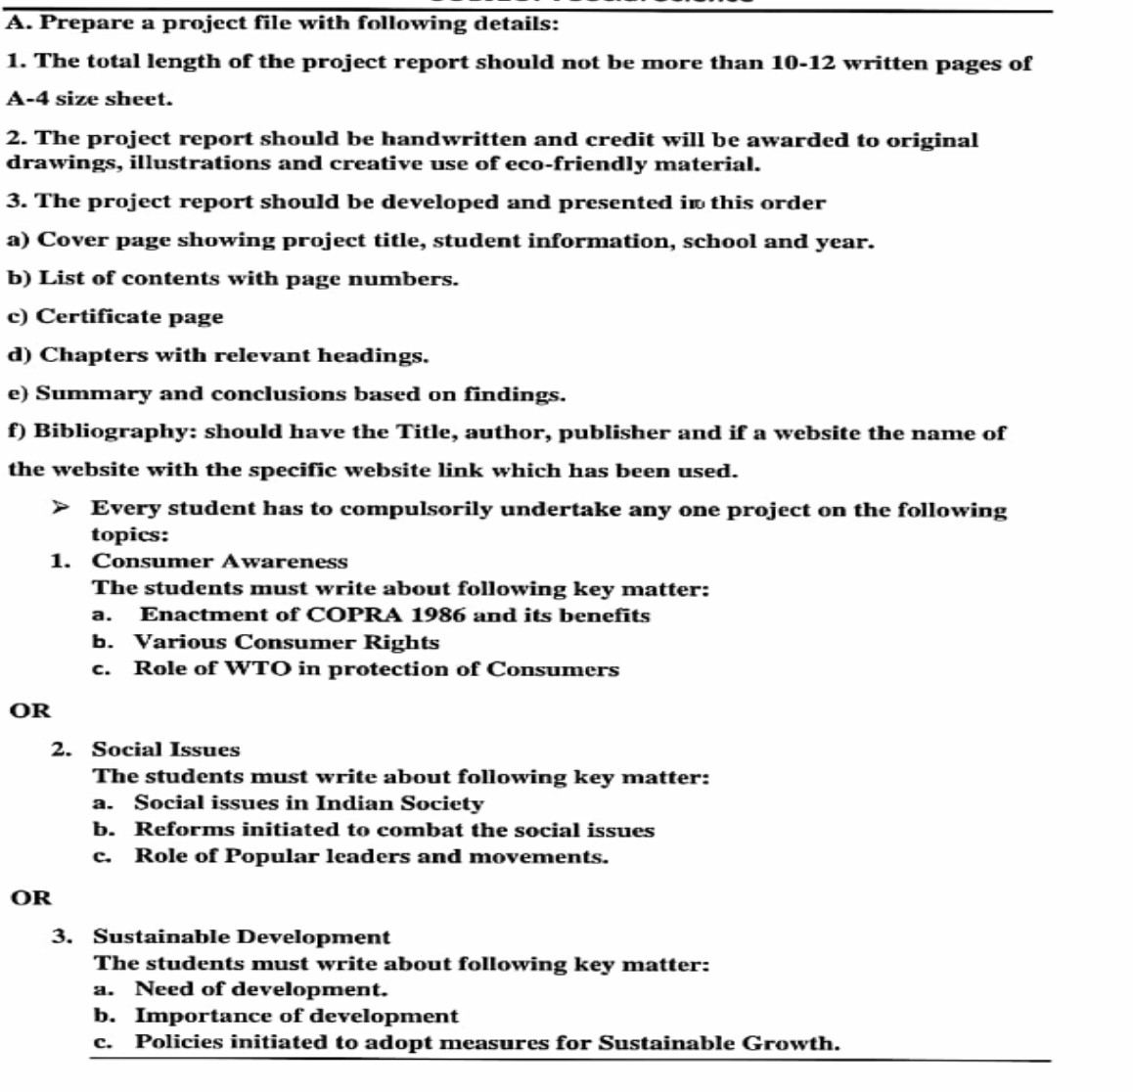
पाठ 2 राम लक्ष्मण परशुराम संवाद की चौपाई कण्ठस्थ कीजिए।
CLASS 10 SOCIAL SCIENCE 1 JUNE TO 10 JUNE 2020 HOLIDAY H.W

NOTE- It is compulsory for all students to complete the project on time with the help of book

WORKSHEET CLASS 10 ENGLISH [Download by given link]
https://drive.google.com/file/d/1AyeLWVi06NuUsFG78iiP0tFUSWOraHoZ/view?usp=sharing

PRAYAG PUBLIC SCHOOL AND COLLEGE
Holiday Home Assignment
Information Technology -402
Class-10
Note:--

- The whole holiday assignment has been divided into three categories SECTION-A,SECTION-B AND SECTION –C make the best use of your time in this lockdown period and complete all your assignment very honestly and sincerely as directed.
- All the assignment in SECTION-A have to be done in Computer Register copy.
- All the assignment in SECTION –B has to be done in your Holiday homework register (Combined register for all the subjects.)
- SECTION-C contaions some projects and activities, which have to be done either homework register or Project/Activity file.
- All the assignment will be throughly checked when school will be open and marks will be given for each assignment.

SECTION-A (Computer Register Copy) Date:-01/06/20 to 10/06/20

Ques-1-List any four characteristics of Enterpreneurship.
Ques-2-Mention any two ways of Scheduling an appointment.
Ques-3-Expalin Blog. Give any two websites that offer free blog services.
Ques-4—List any two factors that affect self. Confidence.
Ques-5—List any five factors causing Ecological Imbalance.
Ques-6—Expalin any three types of Impairment s that impact computer usage.
Ques-7—Expalin Between Client-server Architecture and peer to peer architecture.
Ques-8—List some factors that enhance our oral communication skills.
Ques-9—“Non- Verbal cues complement verbal communication”-Justify.
Ques-10-Riya did not score well in the creative writing section of her English paper. There were a lot of mistakes to vacabulary and writing style.What should she do to improve her written communication? Suggest her the tips.
Ques-11—What are the advantage of Networking?
Ques-12—List any five application based Instant messaging siftware?
Ques-13-State any three rules and entiquettes to be followed while chating on the Internet?
Ques-14-Expalin the purpose of Internet Security?
Ques-15-Explain different kinds of Online threats.
[WISH YOU BEST FOR THE SUMMER VACATION]
PRAYAG PUBLIC SCHOOL AND COLLEGE
Holiday Home Assignment
Information Technology -402
Class-10
Note:--

- The whole holiday assignment has been divided into three categories SECTION-A,SECTION-B AND SECTION –C make the best use of your time in this lockdown period and complete all your assignment very honestly and sincerely as directed.
- All the assignment in SECTION-A have to be done in Computer Register copy.
- All the assignment in SECTION –B has to be done in your Holiday homework register (Combined register for all the subjects.)
- SECTION-C contaions some projects and activities, which have to be done either homework register or Project/Activity file.
- All the assignment will be throughly checked when school will be open and marks will be given for each assignment.

SECTION-B (Holiday Home Register) Date:-10/06/20 to 20/06/20

Ques-1-Write difference between fourth generation of computer and Fifth generation of Computer.
Ques-2-Expalin the term Digital Divide.
Ques-3-What is the need of DataBase. Explain brifly.
Ques-4—Expalin between Cracker and Hacker in computer networking.
Ques-5- What is e-Learning? Mention any two main benefits of e -learning with respect to the use of Information Technology.
Ques-6- Explain about Malware, its types and any two precautionary measure to be taken for information security.
Ques-7-Explain the following terms:--
- Internet b) LAN c) Intant Messaging d) P2P architecture
- Blag f) PAN g) Windows Defender

Ques-8-What is the purposr of HTTPS in the URL address.
Ques-9-In which situation we prefer Star topology over Ring topology?
Ques-10-Write a short notes on Bandwidth and Wi-Fi.
[WISH YOU BEST FOR THE SUMMER VACATION]

Holiday Home Assignment Information Technology -402 Class-10
[Download by given link]
https://drive.google.com/file/d/1bkfBnpBzpXZXzRfCBdq4nDnmKfG0UNw5/view?usp=sharing

